**ITS290F Human Computer Interaction & User Experience Design**

**Lab 6. UI Design**

What you’ll learn in this lab:

* Applying UI design guidelines and principles
* Identifying user error

**1. Readings**

Suggested reference readings

1. The Eight Golden Rules of Interface Design

<http://www.cs.umd.edu/~ben/goldenrules.html>

1. User Interface Design Guidelines: 10 Rules of Thumb

<https://www.interaction-design.org/literature/article/user-interface-design-guidelines-10-rules-of-thumb>

**2. Lab Exercises**

On your own, follow the instructions to finish the exercises. For short text questions, put down your answers in the answer textboxes. For coding exercises, you may edit your code with any text editor. Put your solution code in the solution textboxes when finished.

**Exercise 1**

You are a UI designer who recently hired by an airline, responsible for revamping the UI design of a flight booking system. You have interviewed a focus group comprises customers who frequently use the system to book flights online. One of the major problems identified is they often make **user errors** during the selection of travel dates. This exercise will focus on the discussion of user errors.

Watch a video (<https://www.nngroup.com/videos/slips-vs-mistakes/>) that introduces user errors and answer the following questions.

|  |
| --- |
| 1. What are the two types of user errors in HCI? |
| Your answer.  Slips and Mistakes |

|  |
| --- |
| 1. State the major difference between the (two) types of user error. |
| Your answer.  The major difference between them is that slips are unconscious errors but mistakes are conscious errors. |

|  |
| --- |
| 1. State the key aspects in preventing *slips*. |
| * Your answer. * Offer suggestions * Helpful constraints * Good defaults * Forgiving formatting |

|  |
| --- |
| 1. State the key aspects in preventing *mistakes*. |
| * Your answer. * Understand user’s mental model & expectations * Follow design conventions * Communicate affordances * Allow previewing results of actions |

The following code excerpt is extracted from the problematic UI that accepts the departure date and return date of a roundtrip ticket from the user.

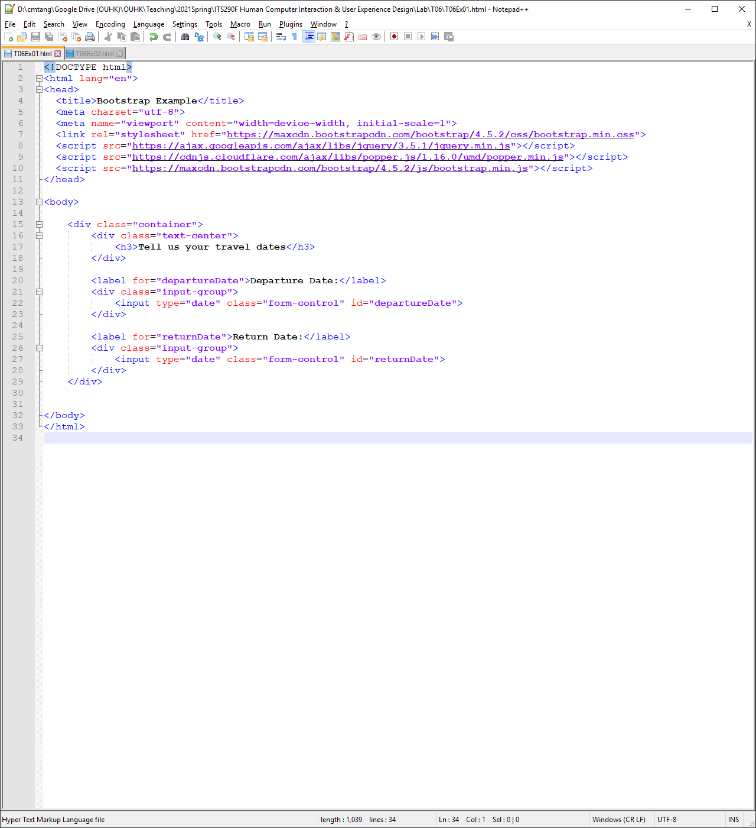

You may also open the webpage file **T06Ex01.html** with a recent web browser. Try to interact with the UI components and identify the potential user errors.

|  |
| --- |
| 1. Which type of user errors is more likely happened in the given UI? |
| Slips |

|  |
| --- |
| 1. With the error type given in E., describe two potential actions that would result user errors. |
| Your answer.  1. Mistyped the departure date with the return date  2. Type the date with wrong format |

If you really have no idea, proceed to Exercise 2 first.

**Exercise 2**

With the findings in Exercises 1, you are about to revamp the date selection UI to prevent the user errors. You have added two alerts on the page that warn the user of invalid selection of departure date and return date. You also implemented a function setDefaultDates() that selects default dates for the users and prohibit the selection of past dates. The webpage with improve UI is in **T06Ex02.html**. You may open the file with a text editor and try it with a web browser.

|  |
| --- |
| 1. Which aspect in Exercise 1. C. is implemented in function setDefaultDates() to prevent slips? |
| Your answer.  Yes |

You might find that the alerts are displayed upon page load without interacting with the user, so you would like to hide them at the moment.

|  |
| --- |
| 1. Update the alert components on the webpage to hide the alert messages when the page first loads. Insert the missing classes to the corresponding tags of both the **T06Ex02.html** file and the textbox below: |
| <div id="departureDateAlert" class="alert alert-danger _d-none__" role="alert">  Departure date was in the past!  </div>    ...  <div id="returnDateAlert" class="alert alert-danger __d-none___" role="alert">  Return date earlier than departure date!  </div> |

**Hints**: See pages 36–37 of L05’s lecture slides.

Then you would like to add the function checkDepartureDate() that checks the validity of the departure date. The almost completed function is as follows.

|  |
| --- |
| 1. Fill in the missing parts of the function checkDepartureDate()in the textbox below and put the completed function in the appropriate region of the **T06Ex02.html** file. |
| function checkDepartureDate() {  // get the current date string (with removal of time)  let today = new Date().toISOString().substr(0,10);  today = new Date(today); // make the date comparable    // get the departure date  let ddate = new Date(document.getElementById("_departureDate__").value);    // compare the dates, hide/show the alert  if (ddate < today) {  document.getElementById("_departureDateAlert______").classList.remove("d-none");  } else {  document.getElementById("_departureDateAlert_______").classList.add("d-none");  }  } |

Now your page should be able to alert the user of an invalid date selection. Next, you would like to add the function checkReturnDate() that checks the validity of the return date. The almost completed function is as follows.

|  |
| --- |
| 1. Fill in the missing parts of the function checkReturnDate()in the textbox below and put the completed function in the appropriate region of the **T06Ex02.html** file. |
| function checkReturnDate() {  let ddate = new Date(document.getElementById("departureDate").value);  let rdate = new Date(document.getElementById("_returnDate_______").value);  if (rdate < ddate) {  document.getElementById("_returnDateAlert_______").classList.remove("d-none");  }  else {  document.getElementById("_returnDateAlert_______").classList.add("d-none");  }  } |

|  |
| --- |
| 1. Which aspect(s) in Exercise 1. C. are satisfied in the updated webpage of Exercise 2? Justify your answer. |
| Your answer.  Good deafult |

**Submission**

You will get 0 to 3% of OCAS score upon completing the lab exercises.

1. Put your solution code inside the answer boxes and save the file.
2. Upload this file via the corresponding submission link on OLE.

**Note:**

1. The submission deadline is 23:59 of the forthcoming Thursday. The submission link will be closed after the deadline.
2. We mainly focus on the correctness and quality when grading your work.
3. Make sure you submitted a correct file. You can resubmit your work before the deadline.

1. DO NOT modify the layout and format of this document, and DO NOT save it as other file formats, i.e., PDF. Your work will be extracted using an automated document parsing tools for grading.

--- End ---